**Part 1**

|  |  |  |  |  |  |  |
| --- | --- | --- | --- | --- | --- | --- |
|  |  |  | 1v1 ROC AUC scores | | 1vRest ROC AUC scores | |
| Model | Test Accuracy | Macro AUC | Macro | Wieghted by Prevalence | Macro | Wieghted by Prevalence |
| Chapter 11 one hidden layer | 95.89% | 0.995459364 | 0.995413 | 0.995459 | 0.995413 | 0.995459 |
| Chapter 11 two hidden layers | 96.16% | 0.996477583 | 0.996433 | 0.996478 | 0.996433 | 0.996478 |
| Keras two hidden layers | 94.07% | 0.995177091 | 0.995154 | 0.99518 | 0.995154 | 0.99518 |

AUC graphs:

Keras:

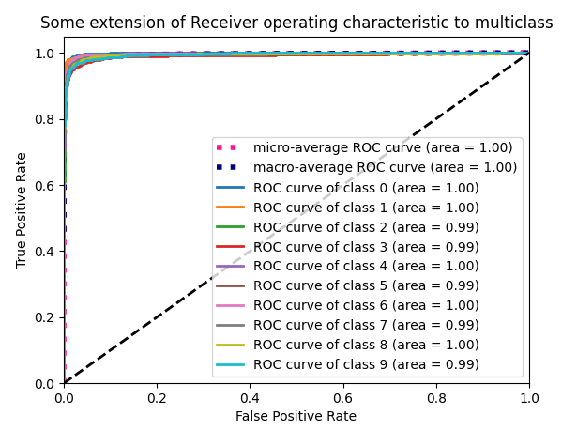

Chapter 11 one hidden layer:

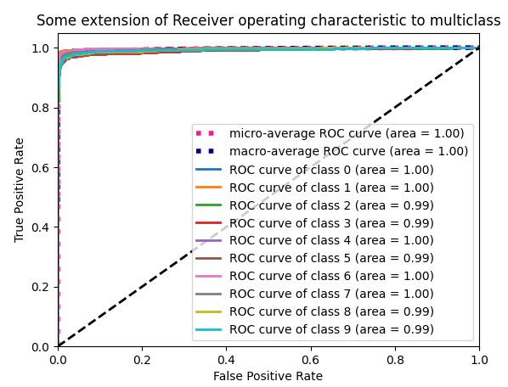

Chapter 11 two hidden layers:

**Part 2:**

Preprocessing:

Crop from center of the image for an image size of (250,250,3)

InceptionV3

Total params: 22,011,782

Trainable params: 21,977,350

Non-trainable params: 34,432

# of layers: 313

Inception-v3 is a CNN architecture from the Inception family that makes several improvements including using Label Smoothing, Factorized 7 x 7 convolutions, and the use of an auxiliary classifer to propagate label information lower down the network (along with the use of batch normalization for layers in the sidehead).

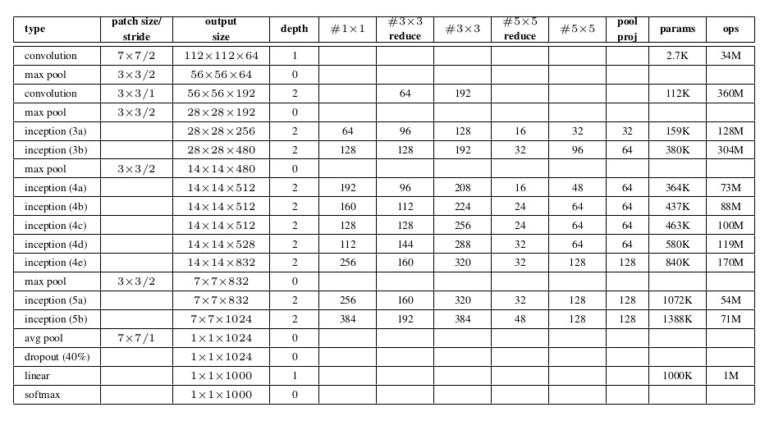

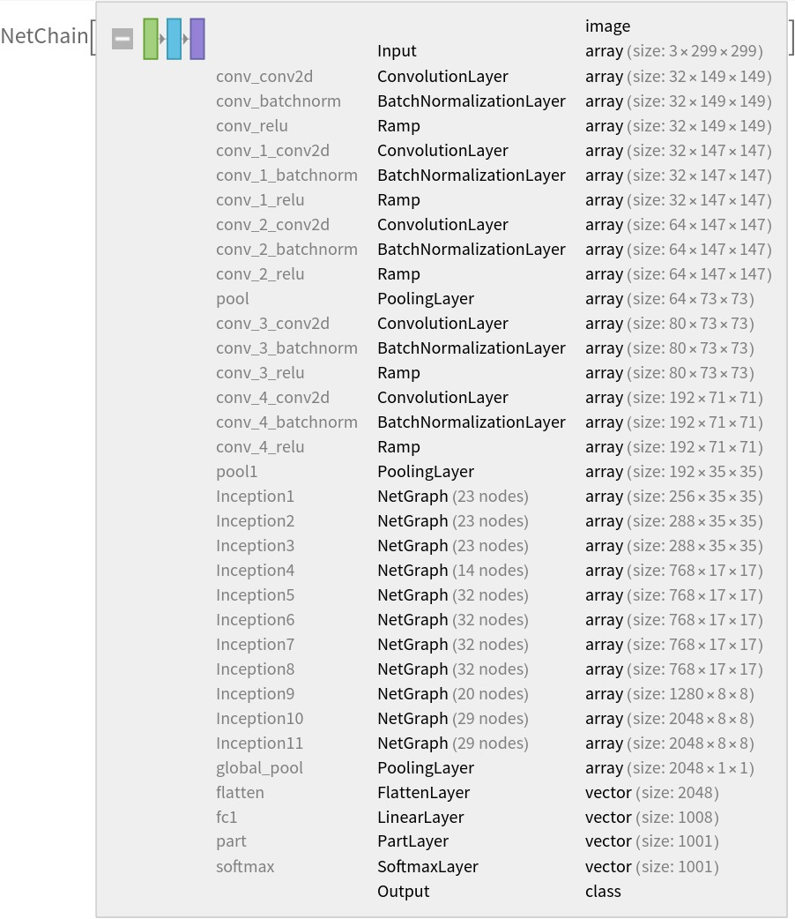

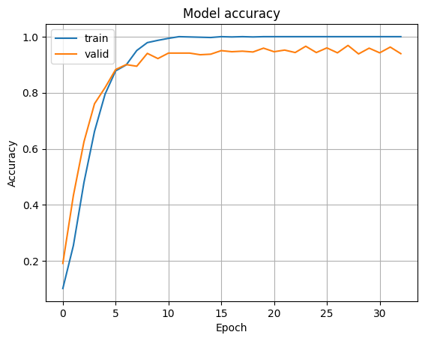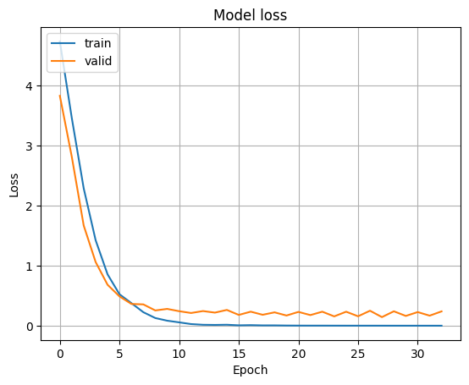InceptionV3 seed 3856 Test accuracy: 0.9643380641937256

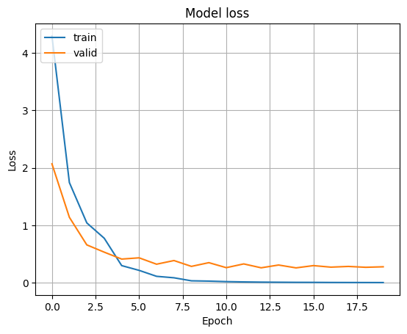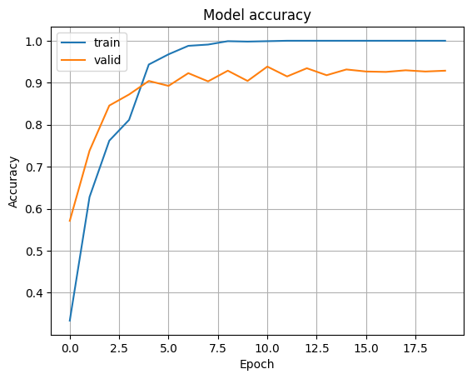InceptionV3 seed 42 Test accuracy: 0.9736199378967285

Xception

Total params: 21,070,478

Trainable params: 21,015,950

Non-trainable params: 54,528

# of layers: 134

Xception (which stands for “Extreme Inception”) architecture has 36 convolutional layers forming the feature extraction base of the network.

The data first goes through the entry flow, then through the middle flow which is repeated eight times, and finally through the exit flow. Note that all Convolution and Separable Convolution layers are followed by batch normalization (not included in the diagram). All Separable Convolution layers use a depth multiplier of 1 (no depth expansion).

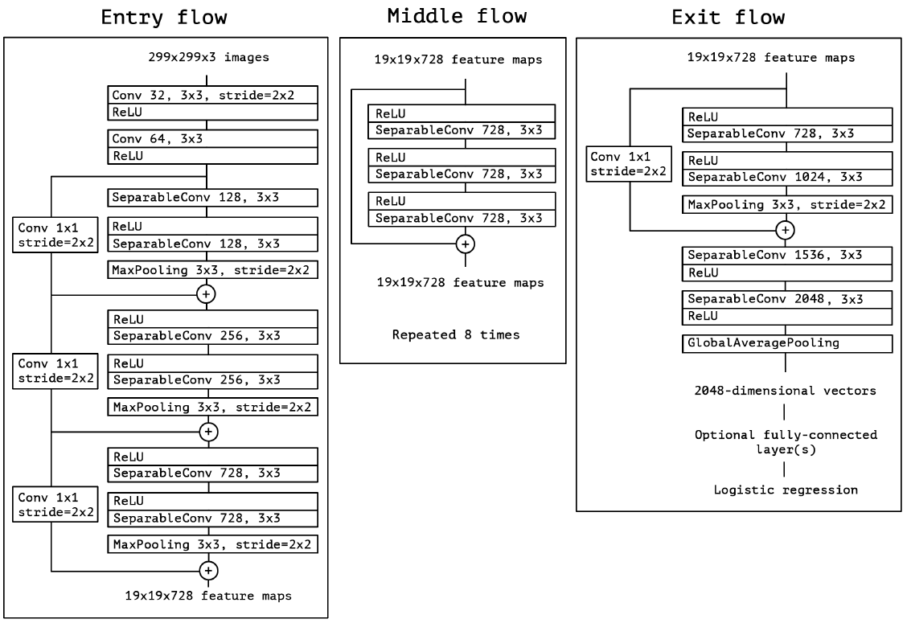

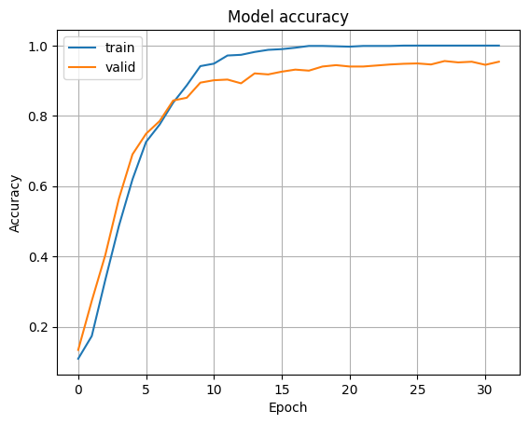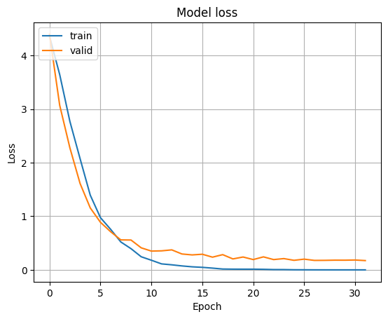Xception seed 17 Test accuracy: 0.9638495445251465

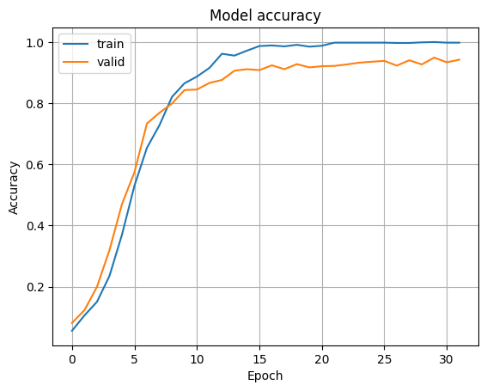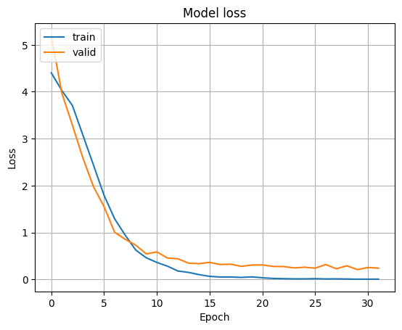Xception seed 567485 Test accuracy: 0.9682462215423584

|  |  |  |
| --- | --- | --- |
| Model | Seed | Test ACC |
| InceptionV3 | 3856 | 0.964338064 |
| InceptionV3 | 42 | **0.973619938** |
| Xception | 17 | 0.963849545 |
| Xception | 567485 | 0.968246222 |